

East West University

Department of Computer Science & Engineering

**Course Title:** Database System

**Course Code:** CSE301  
**Experiment No:** 07

**Semester:** Fall, 2015

**Section:** 01

**Submitted By:**

S. M. Amirul Islam

ID: 2013-1-60-048

**Introduction**

**Problem:**

The tables are as follows

**Borrower**

|  |  |
| --- | --- |
| **Loan_no** | **Customer_id** |
| 245 | 105 |
| 310 | 925 |
| 356 | 820 |
| 450 | 820 |

**Loan**

|  |  |  |
| --- | --- | --- |
| **Loan_no** | **Amount** | **Branch_name** |
| 245 | 10000 | AB |
| 310 | 15000 | BD |
| 350 | 8000 | BD |
| 450 | 7000 | CD |

**Depositor**

|  |  |
| --- | --- |
| **Acct_no** | **Customer_id** |
| 101 | 307 |
| 103 | 925 |
| 106 | 820 |

**Customer**

|  |  |  |
| --- | --- | --- |
| **Customer_id** | **Name** | **Address** |
| 105 | Asif | Dhaka |
| 925 | Ana | Sylhet |
| 820 | Dona | Raj |
| 207 | Alif | Bogra |

**Account**

|  |  |  |
| --- | --- | --- |
| **Acct_no** | **balance** | **Branch_name** |
| 101 | 20000 | BD |
| 103 | 50000 | CD |
| 206 | 70000 | AD |

1. Show the customer id who have loan or account.

SQL:(select customer_id from borrower)intersect(select customer_id from

depositor)

Output Screenshot: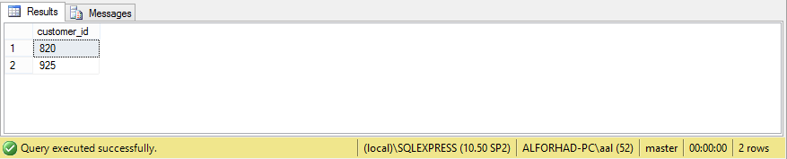

1. Show the customer id who have both loan and account.

SQL:select customer_id from borrower where customer_id in(select customer_id

from depositor)

Output Screenshot: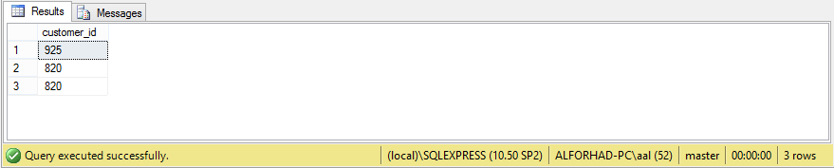

1. Show the customer id who have account but no loan.

SQL:select customer_id from depositor where customer_id notin(select

customer_id from borrower)

Output Screenshot: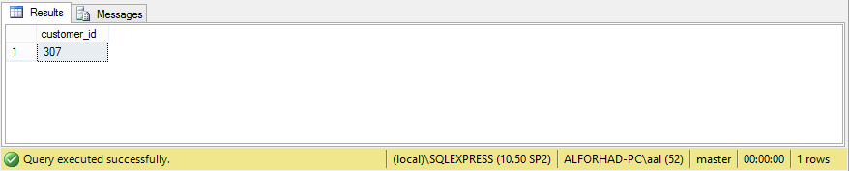

1. Show the customer id who have loan but no account.

SQL:(select customer_id from borrower)except(select customer_id from

depositor)

Output Screenshot: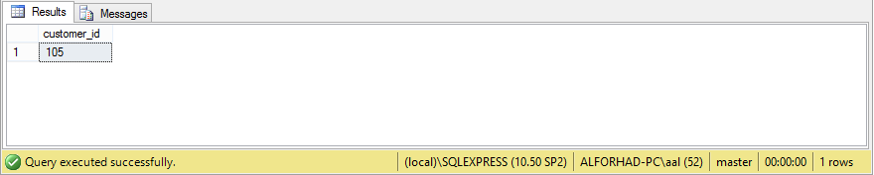

1. Show the loan no. where amount is more than balance of some loan of BD branch.

SQL:select loan_no from loan where amount >some(select amount from loan

where branch_name='BD')

Output Screenshot: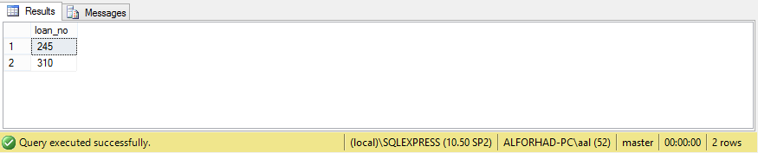

1. Show the loan no where amount is more than balance of any loan of BD branch.

SQL:select loan_no from loan where amount >any(select amount from loan

where branch_name='BD')

Output Screenshot: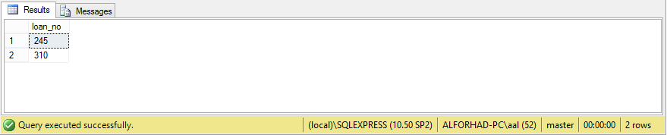

1. Show the loan no where amount is more than balance of all loan of BD branch.

SQL:select loan_no from loan where amount >all(select amount from loan

where branch_name='BD')

Output Screenshot: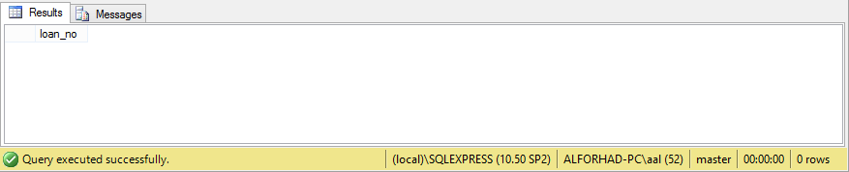

1. Show the loan no whose amount is lowest.

SQL:select loan_no from loan where amount=(selectmin(amount)from loan)

Output Screenshot: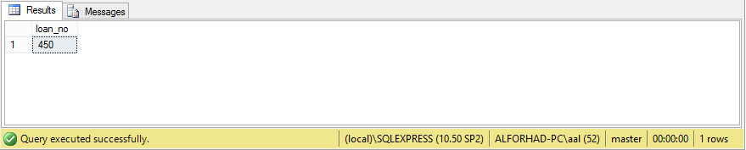

1. Show the highest balance.

SQL:select balance from account where balance=(selectmax(balance)from

account)

Output Screenshot: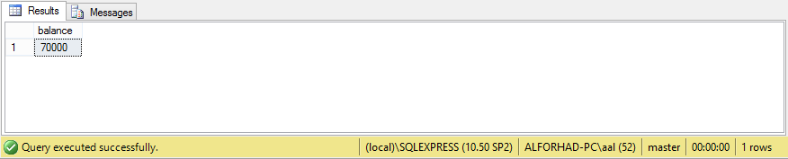

1. Show the branch name of the highest balance from the containing accounts.

SQL:select branch_name from account where balance=(selectmax(balance)from

account)

Output Screenshot: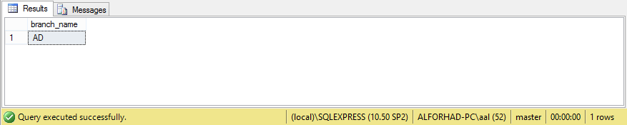

1. Show the average amount.

SQL:selectavg(amount)as avg_amnt from loan

Output Screenshot: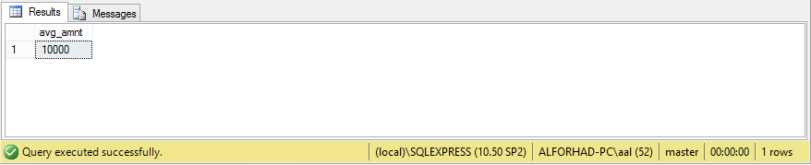

1. Show average amount of each branch.

SQL:select branch_name,avg(amount)as avg_amnt from loan groupby branch_name

Output Screenshot: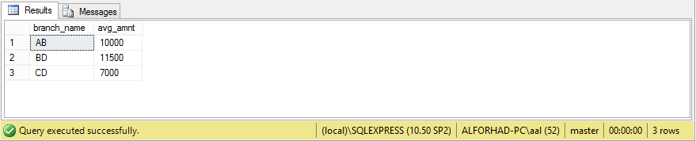

1. Show the branch name whose average amount is greater than or equal to each balance average amount.

SQL:select branch_name from loan groupby branch_name having

avg(amount)>=all(selectavg(amount)from loan groupby branch_name)

Output Screenshot: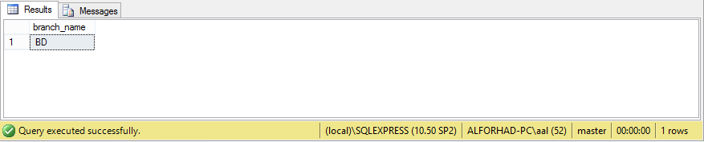

1. How many account are there.

SQL:selectcount(acct_no)as tot_acc from account

Output Screenshot: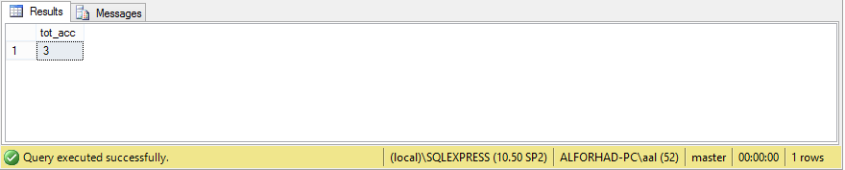

1. Show the average amount of each branch where average balance is greater than 8000.

SQL:select branch_name,avg(amount)as avg_amnt from loan groupby branch_name having

avg(amount)>8000

Output Screenshot: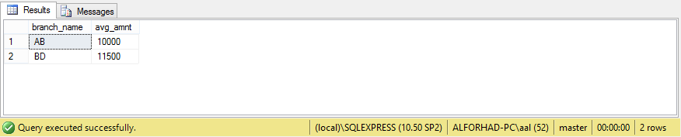

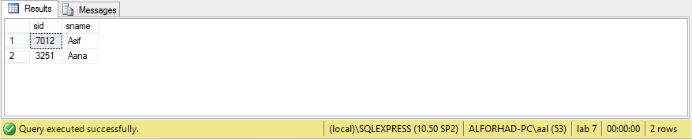

**Discussion:**

At the end of this LAB I have learned the basic ideas of database management system. I also learned about Set Operations of Database.